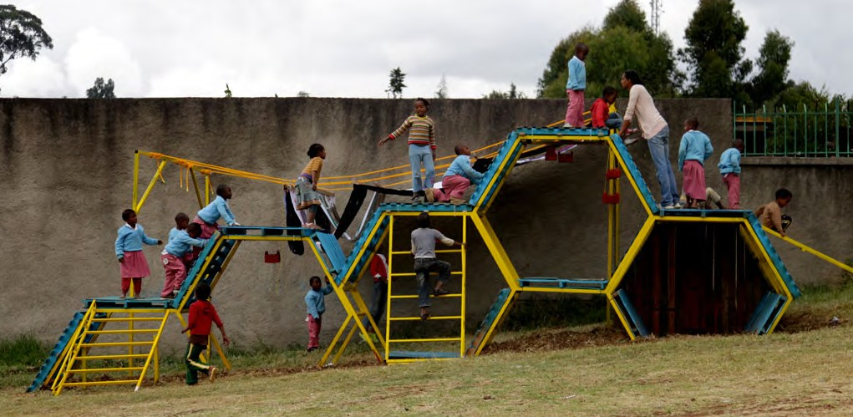
Source: (Perez-Llantada & Woldesenbet, 2019)

In reference list:
Perez-Llantada, M.P. & Woldesenbet,M., 2019, Self-made playground: The house of the lost children, viewed 26 April 2022, from https://thecityateyelevel.com/app/uploads/2019/11/SELF-MADE.pdf

